**EXP NO : 4B SHARMILEE B**

**DATE: 19/08/24 231901049**

**PACKET SNIFFING USING WIRESHARK**

**AIM:**

**Exercises**

1. **Capture 100 packets from the Ethernet: IEEE 802.3 LAN Interface and save it.**

**Procedure**

* + Select Local Area Connection in Wireshark.
  + Go to capture option
  + Select stop capture automatically after 100 packets.
  + Then click Start capture.
  + Save the packets.

**Output**

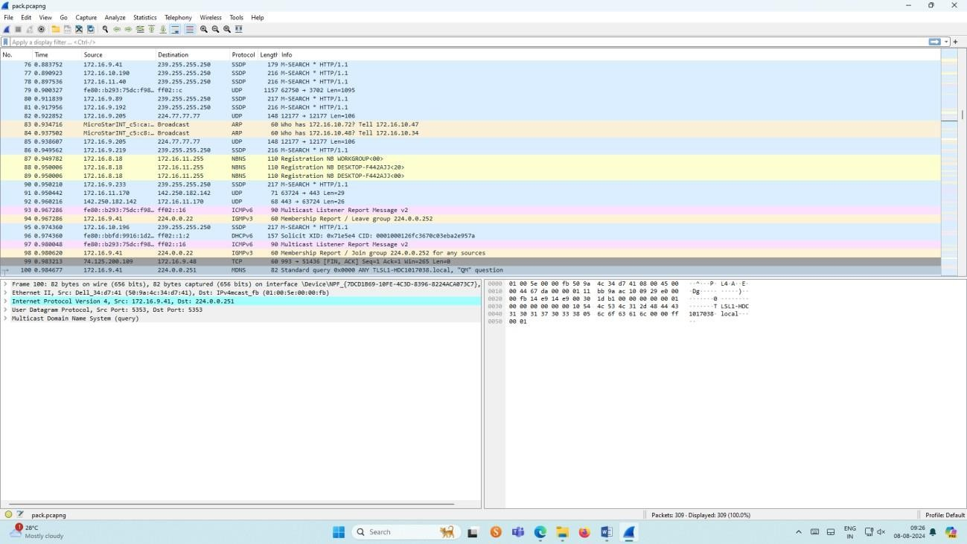

1. **Create a Filter to display only TCP/UDP packets, inspect the packets and provide the flow graph.**

**Procedure**

* + Select Local Area Connection in Wireshark.
  + Go to capture option
  + Select stop capture automatically after 100 packets.
  + Then click Start capture.
  + Search TCP packets in search bar.
  + To see flow graph click StatisticsFlow graph.
  + Save the packets.

**Output:**

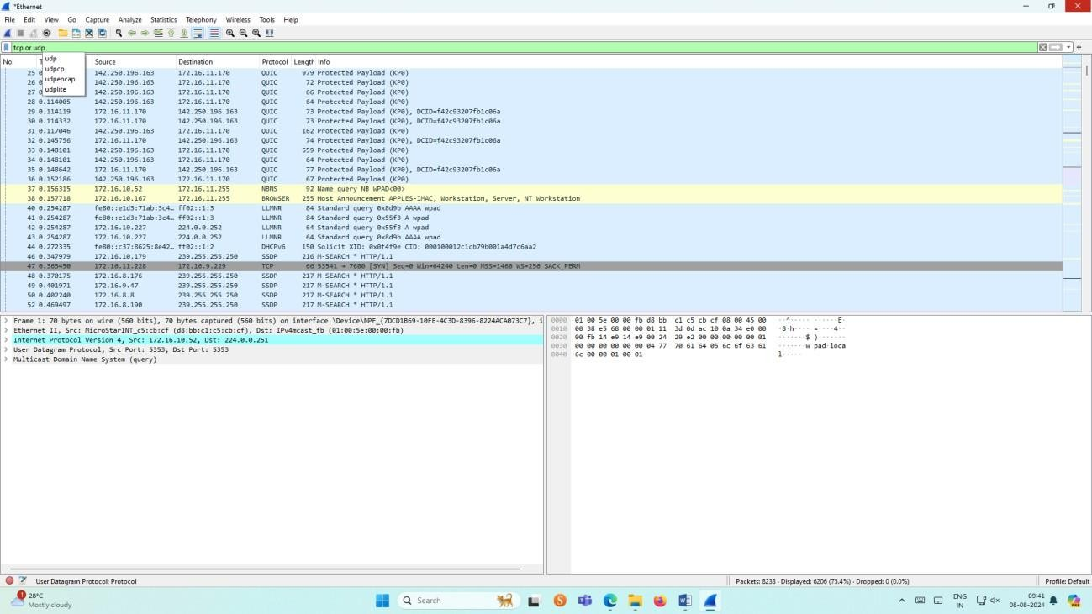

**Flow Graph output**

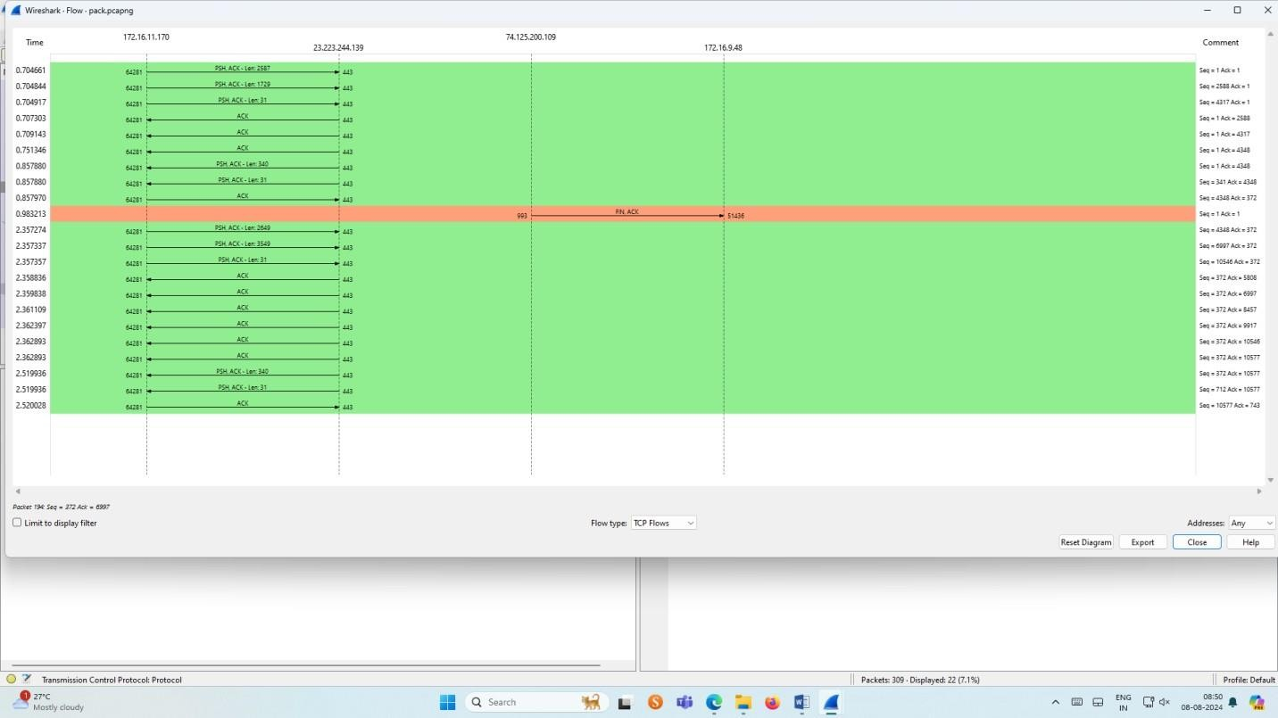

**Inspecting the packets**

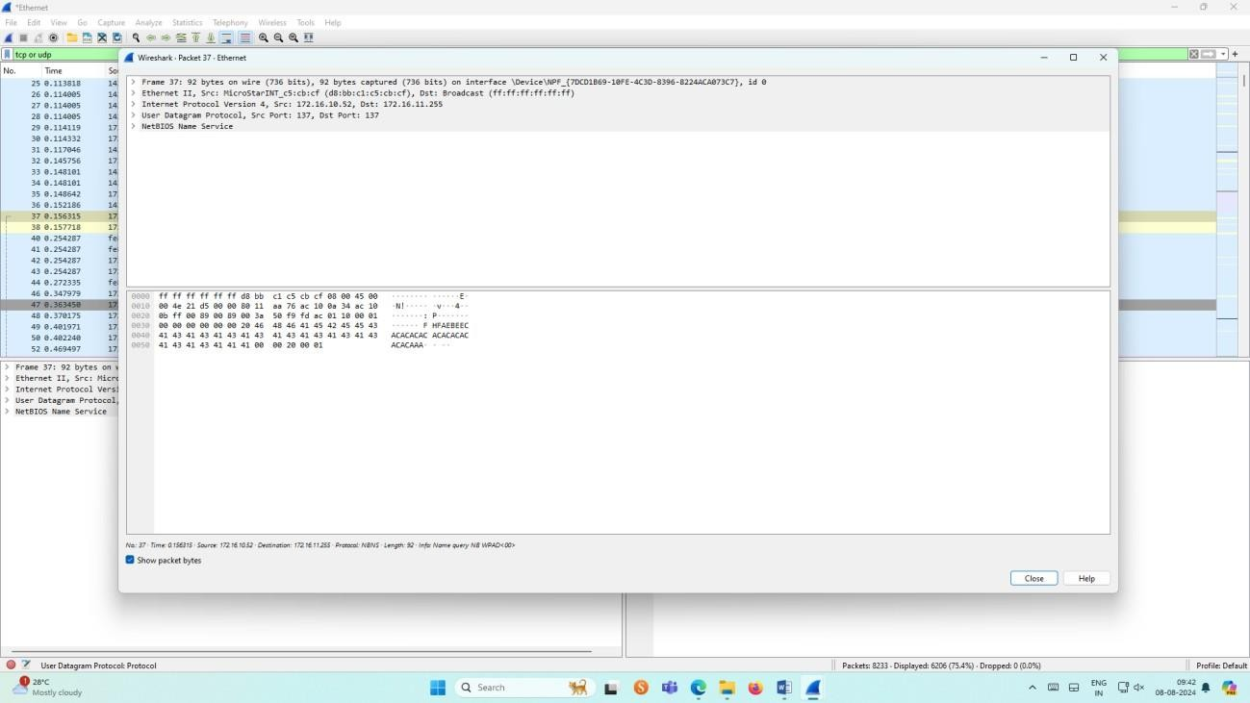

1. **Create a Filter to display only ARP packets and inspect the packets.**

**Procedure**

* + Select Local Area Connection in Wireshark.
  + Go to capture option
  + Select stop capture automatically after 100 packets.
  + Then click Start capture.
  + Search ARP packets in search bar.
  + Save the packets.

**Output**

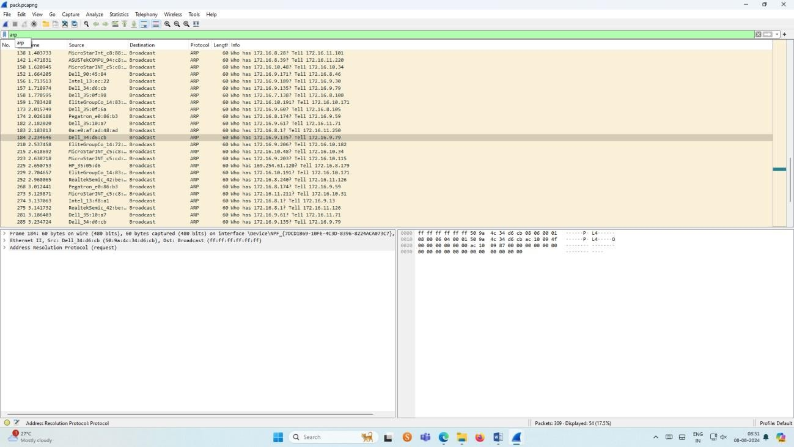

**Inspecting the packets**

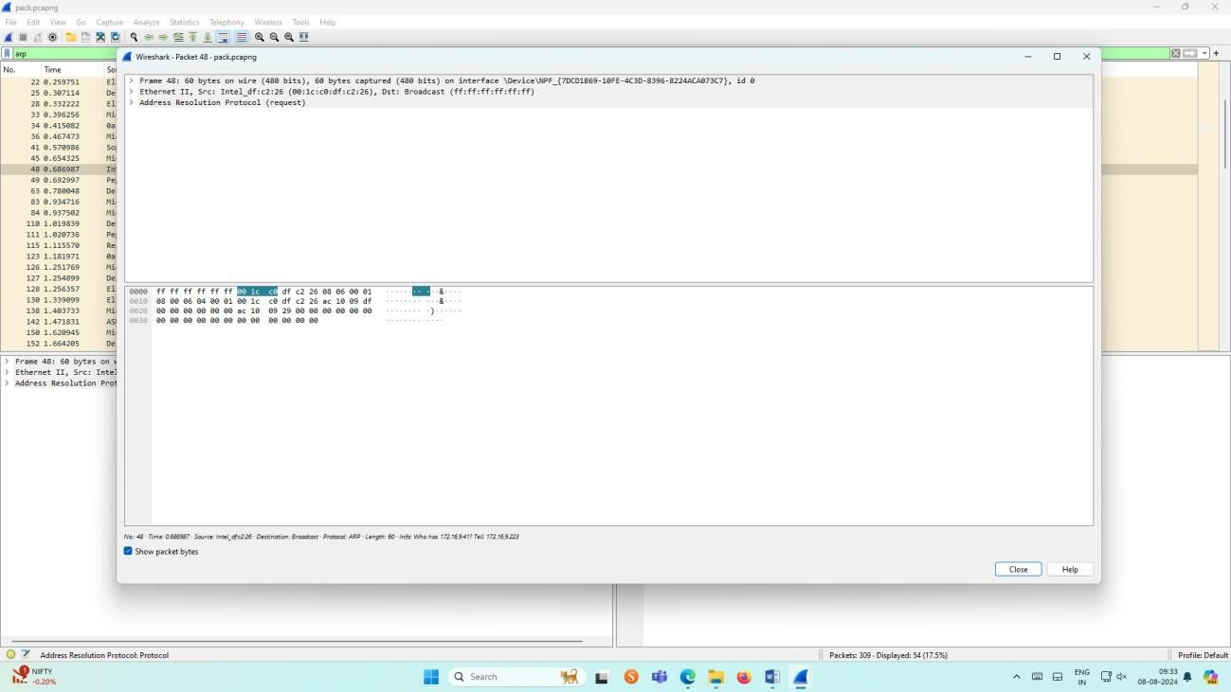

1. **Create a Filter to display only DNS packets and provide the flow graph.**

**Procedure**

* + Select Local Area Connection in Wireshark.
  + Go to capture option
  + Select stop capture automatically after 100 packets.
  + Then click Start capture.
  + Search DNS packets in search bar.
  + To see flow graph click StatisticsFlow graph.
  + Save the packets.

**Output**

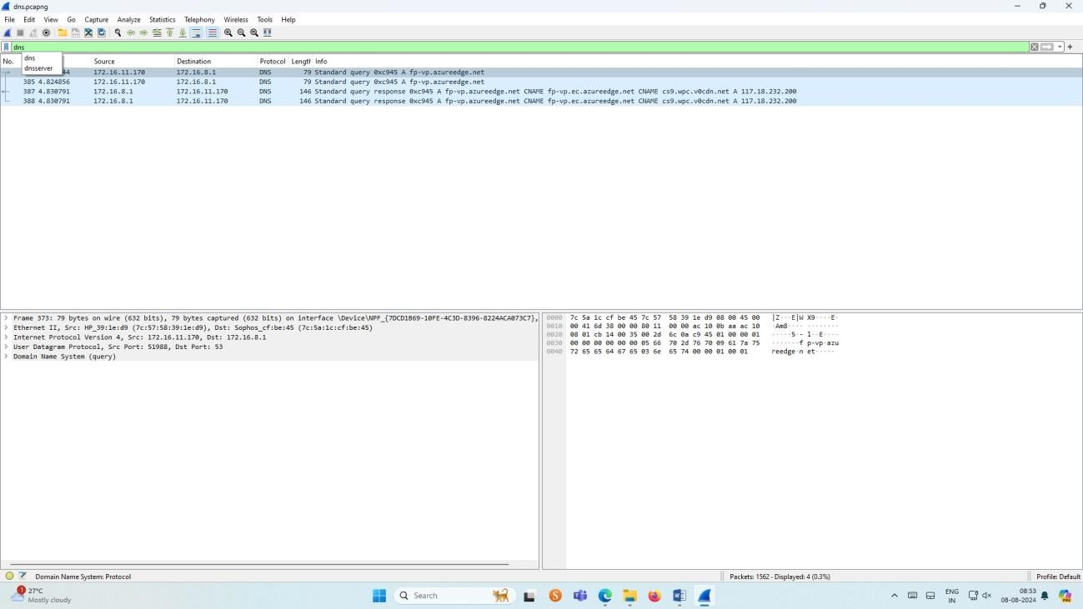

**Graph output**

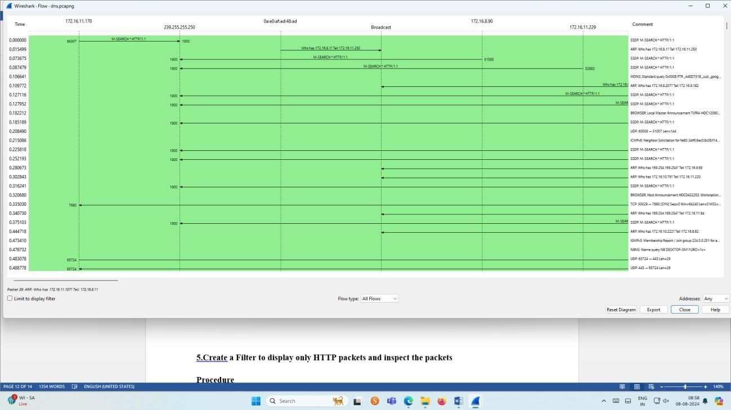

1. **Create a Filter to display only HTTP packets and inspect the packets**

**Procedure**

* + Select Local Area Connection in Wireshark.
  + Go to capture option
  + Select stop capture automatically after 100 packets.
  + Then click Start capture.
  + Search HTTP packets in the search bar.
  + Save the packets.

**Output**

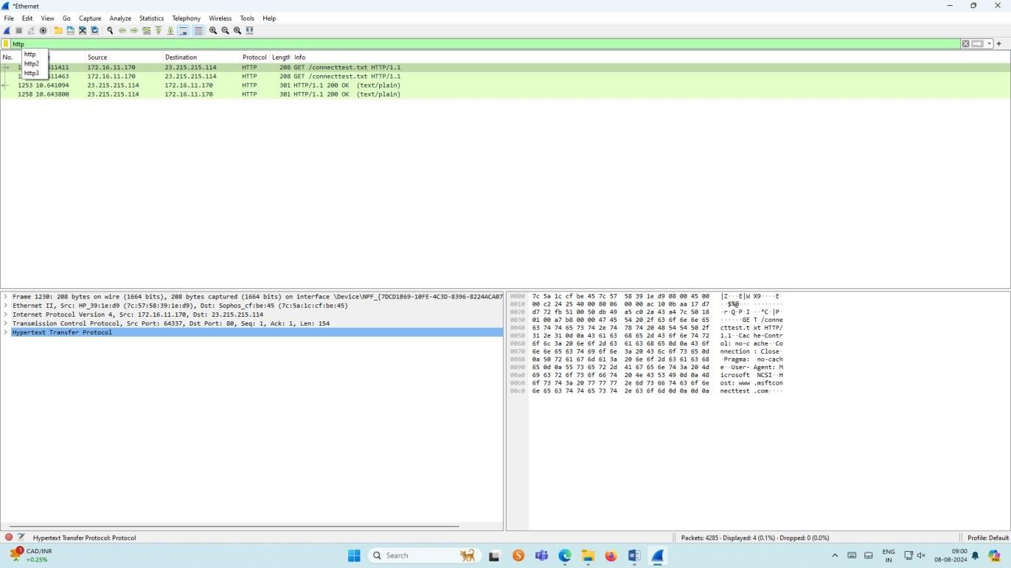

**Flow Graph output**

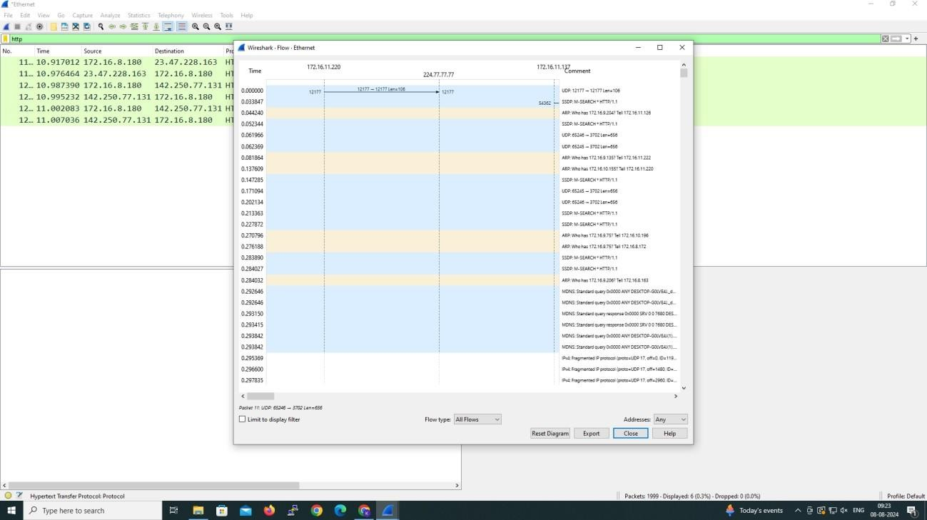

**Inspecting the packets**

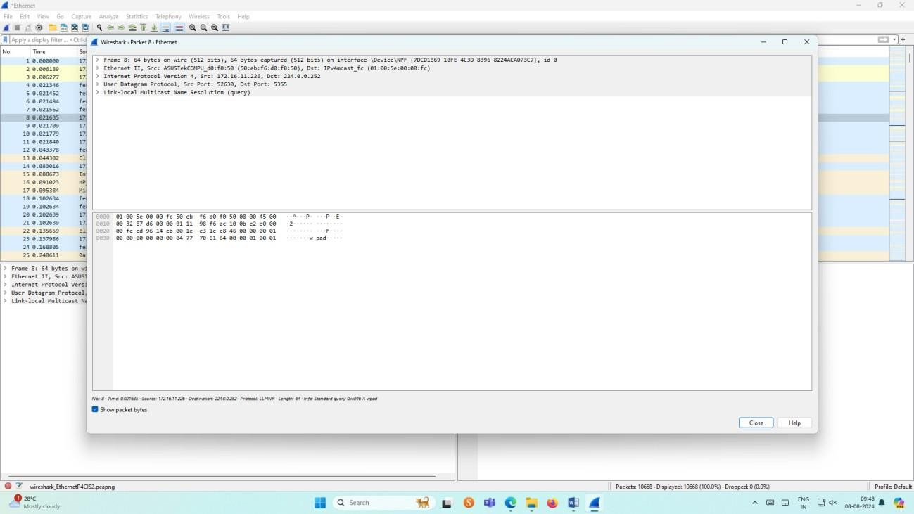

1. **Create a Filter to display only IP/ICMP packets and inspect the packets.**

**Procedure**

* + Select Local Area Connection in Wireshark.
  + Go to capture option
  + Select stop capture automatically after 100 packets.
  + Then click Start capture.
  + Search ICMP/IP packets in search bar.
  + Save the packets

**Output**

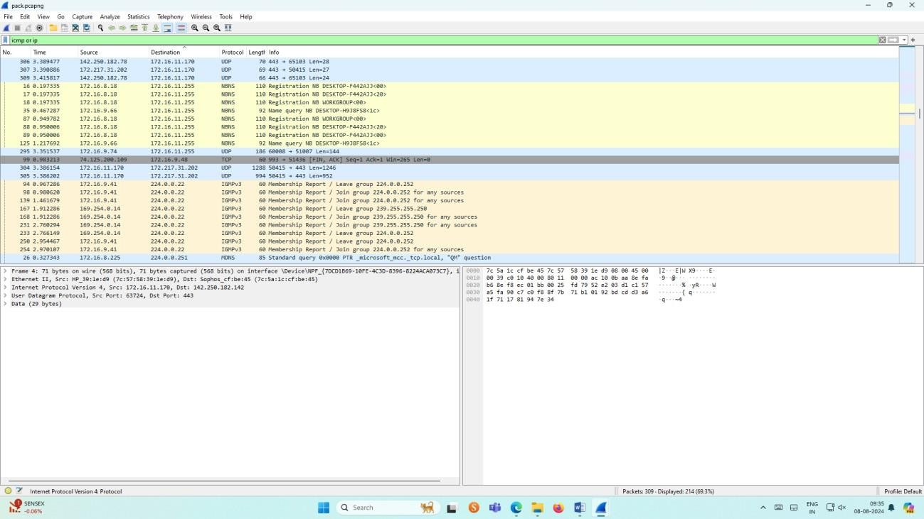

**Flow Graph output**

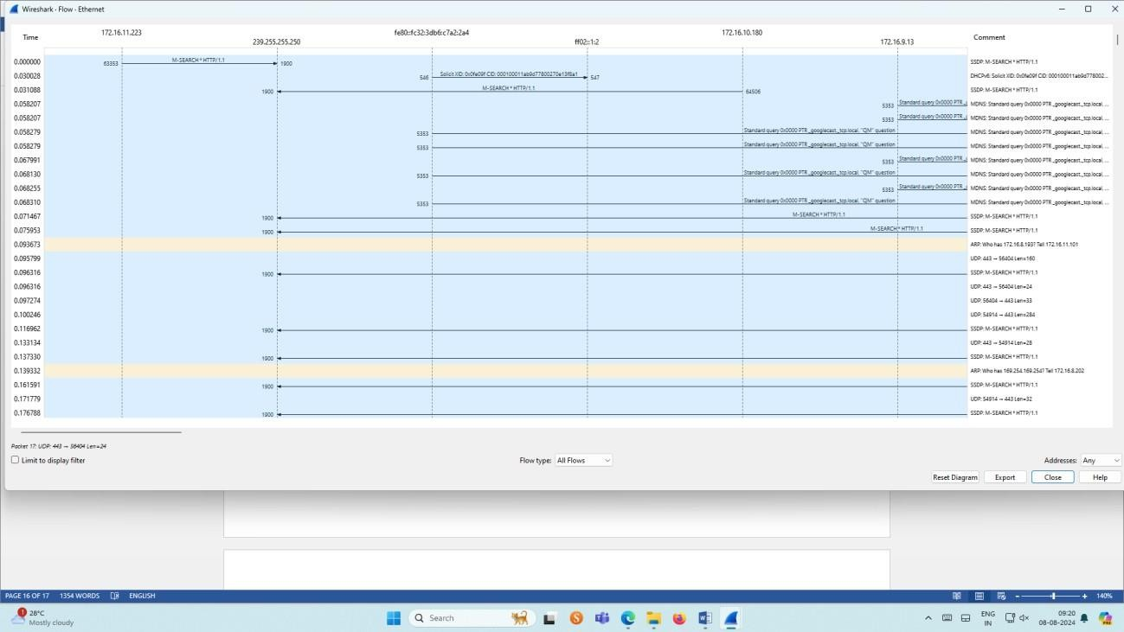

**Inspecting the packets**

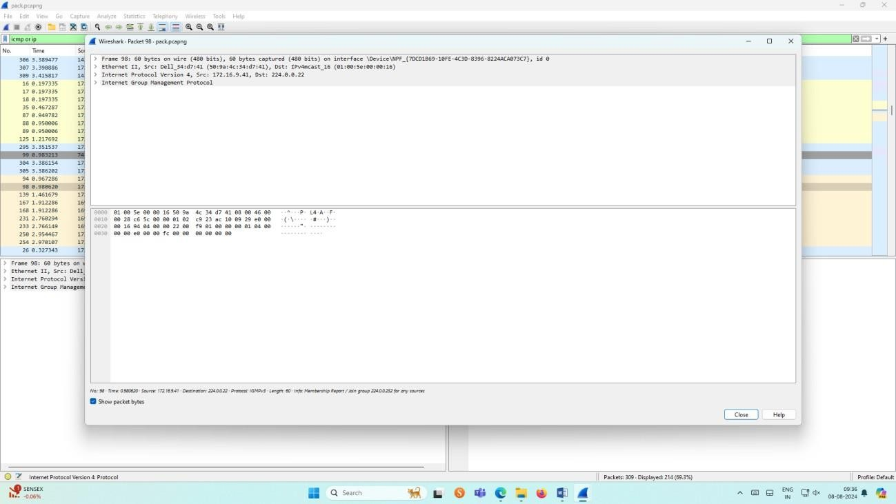

1. **Create a Filter to display only DHCP packets and inspect the packets.**

**Procedure**

* + Select Local Area Connection in Wireshark.
  + Go to capture option
  + Select stop capture automatically after 100 packets.
  + Then click Start capture.
  + Search DHCP packets in search bar.
  + Save the packets

**Output**

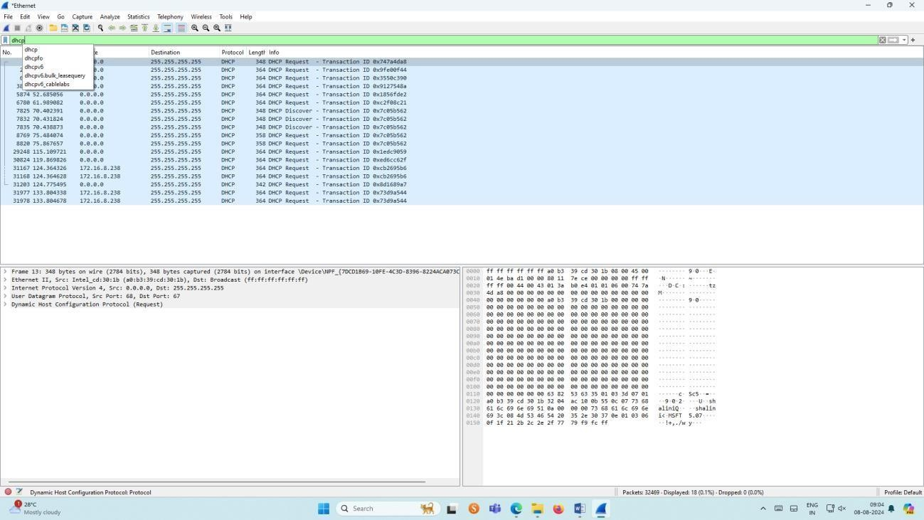

**Inspecting the packets**

